SSIS Catalog Clean-up

The SSIS catalog is the central location for working with Integration Services (SSIS) project that developed in SSIS server. SSISDB database t is automatically created when implementing the SSIS catalog (Right click on the Integration Services Catalogs folder, you can "Create Catalog" and the SSISDB is created).

You are able to clean up SSIS catalog database to increase free space in F drive or the drive runs out of disk space.

There are two steps that we need to perform the SSIS Catalog cleanup.

**1) Change is the retention period .The retention period defaults to 365 days. It is wise to check with Analytics team before changing the retention period.**

**Go to Integration services catalogs and then right click the SSISDB and select properties.**

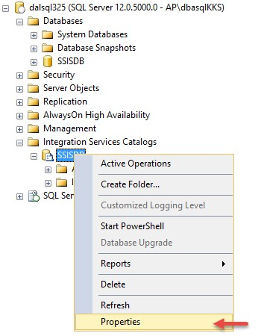

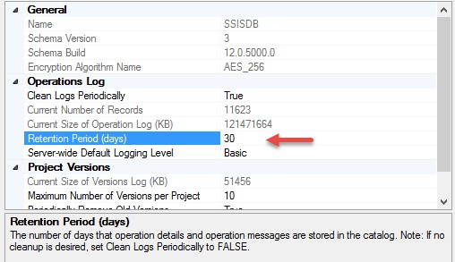

**2) Start Process to clean up old data.**

**Run SSIS Server Maintenance Job.**

The job contains two steps

**Step 1-** SSIS Server Operation Records Maintenance .Command: EXEC [internal].[cleanup_server_retention_window] .

**Step 2**- SSIS Server Max Version Per Project Maintenance Command : EXEC [internal].[cleanup_server_project_version].